Project Proposal

Floor Cleaning Robot (VBot210)

Name of the Student : Vatsal N Shah
Roll No. : IU1241090055
Branch : Electronics & Communication
Semester : 7th
Date : 31.08.15

Project Mentor : Abhishek Vaghela

Indus Institute of Technology and Engineering
Indus University
Rancharda, Via Thaltej
Ahmedabad-382 115

Definition and Objectives of the Project:

The purpose of this project is to design and implement a semi-automated Floor cleaning robot (VBot210). It will have several criteria that are efficient, organized and user-friendly, which meets human needs.

The system requires to:
1. Remove the debris and large particles from the floor.
2. Wet clean the floor with fresh water.
3. Remove the dirty water and leave the floor as dry as possible.
4. Deliver a working prototype, which demonstrates the cleaning strategy.
5. Control Autonomous and using Phone application.

Scope of Project:

The scope of this project is to develop fully functioning product. System is semiautonomous, which is control by phone Application or Autonomously. Light will be turn on in the system, if there is darkness. Display time, day and name functionality is on the bot. Its limitation is, it can’t be climb any obstacles. If, Bin will be full it can’t detect on its own.

Design Specifications:

Technical Details | VBot 210
Automatic Charging | Yes
Automatic shutdown if robot is picked up | No
Battery description. | 14.4V 6.6 A-hr. NiMH
Bin Availability | Yes
Charging Time | 4 [H]
Cleaning Area | 100 [m²]
Climb Obstacle | n/a
Control | Automatic/ Mobile App
Dimensions (DXH) | 400X150 [mm]
Dim Light sensing | Yes
Full Bin Indicator | No
Low voltage beeping indicator. | No
Linear speed | 0.3 m/sec
Run Time | 100 [min]
Scheduled Cleaning | Yes
Side Brushes | No
Suction Power | No [W]
Weight | 6 [kg]
Water Tank | Yes (0.6l)
Table1: Design Specification

Implementation Plan

Implementation plan for VBot210 in the block diagram described below:
Requirements Specification

Fabrication
Evaluation and
Testing
Project Planning
Design Generation

Research Work

Fig1: Block diagram
- To implement the project, starts with the research work and generation of the design and concept.
- The design work of VBot210 will be designed in AutoCAD software, mechanical tool.
- Vacuum mechanism and defined its specifications
- Test charging and discharging time
- Programming for different sensors as described below will be test using microcontroller.
- To convert one mode to another mode using switch case
- Ultrasonic sensor/IR Sensor testing with wheels
- LCD Display programming for display on the VBot210.
- To change the speed using PWM
- LDR Sensor programming
- Check Bluetooth module with controller

Design Details
Here is the design, top view and bottom view of Vbot210.
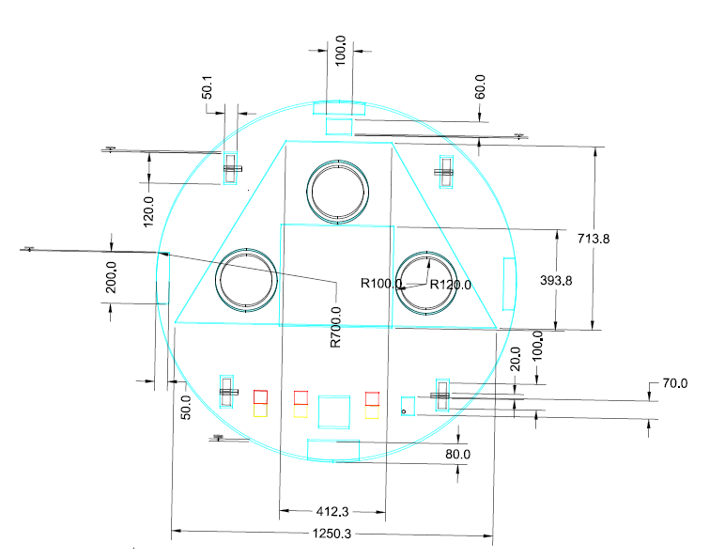
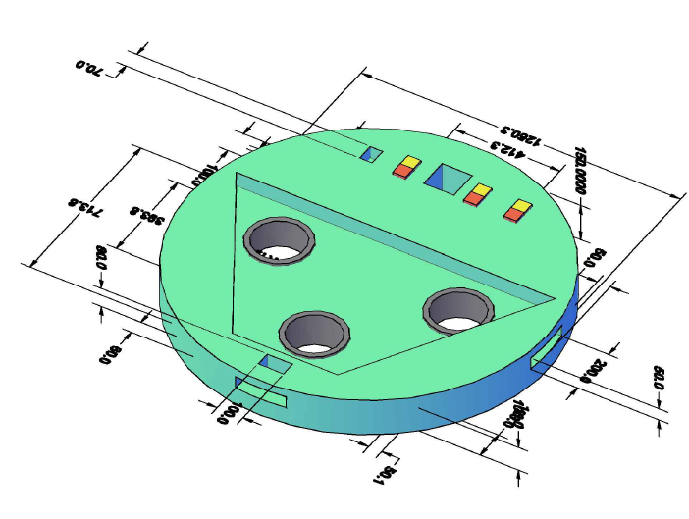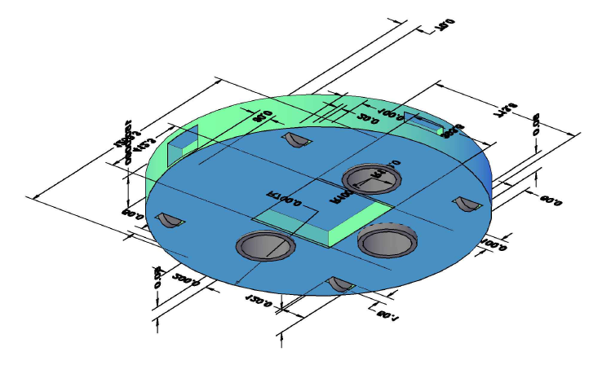
Fig 2.0 Top View, Fig2.1 Side View, Fig 2.2 Bottom View
Verification Plan:

To verified the working and functionality of prototype VBot210 for different category tools are listed as below:
- Design of Vbot210 – AutoCAD
- Sensor testing – Proteus
- Programming testing – Arduino microcontroller
- Other measurements – Multimeter

Cost:

No. | Element | Quantity | Price (Rs.) | Total Price (Rs.)
1 | IR/ Ultrasonic Sensor | 3 | 200 | 600
2 | Bluetooth Module HC – 06 | 1 | 500 | 500
3 | Arduino Mega | 1 | 1200 | 1200
4 | Wheels | 4 | 200 | 800
5 | 12V DC Motor for wheel | 4 | 300 | 1200
6 | Shaft for Motor | 4 | 50 | 200
7 | Battery (Rechargeable) | 1 | 500 | 500
8 | Charger for battery | 1 | 500 | 500
9 | Wires (Connection) | 50 | 6 | 300
10 | Body material (round shape) | 1 | 200 | 200
11 | Fabrication of all material | 1 | 1500 | 1500
12 | 12V DC Vacuum tube | 3 | 100 | 300
13 | Motor for vacuum tube | 3 | 200 | 600
14 | LCD Display | 1 | 200 | 200
15 | Touch switch | 3 | 100 | 300
16 | H - bridge | 2 | 300 | 300
17 | LM7805 IC | 5 | 10 | 50
18 | LDR Sensor | 1 | 200 | 200
19 | 5 Bright LEDS | 5 | 10 | 50
20 | Screw (all size) | 100 | 500 | 500
Total |  |  |  | 10000
Table2: Costing
Schedule:

Time schedule for the overall project in the form of a chart showing below:
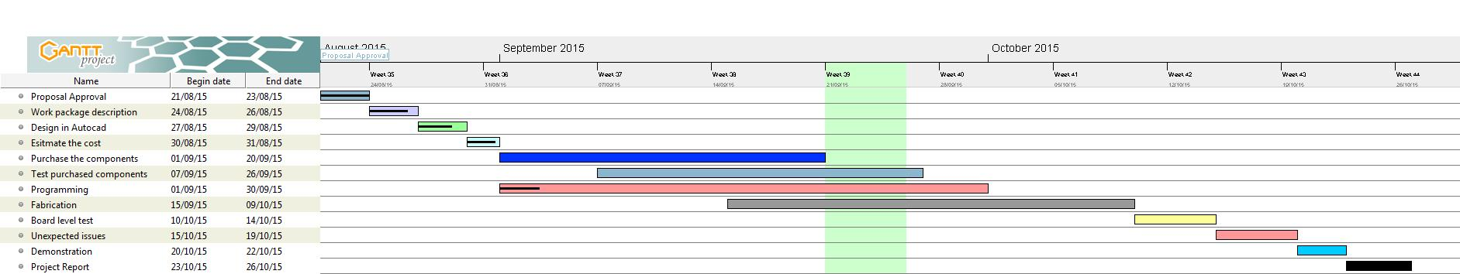

Deliverables:

At the end of the project Design report, Hardware, Code files, and Project report. It will be functioning body.

